Use ITI :

**1) Data Manipulating Language:**

1. Insert your personal data to the Student table as a new Student in department number 30.
2. 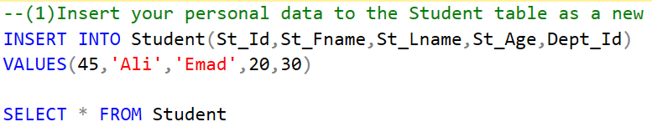
3. Insert Instructor with personal data of your friend as new Instructor in department number 30, Salary= 4000, but don’t enter any value for bonus.
4. 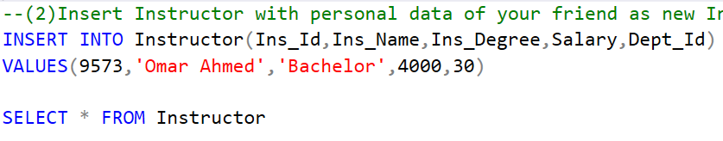
5. Upgrade Instructor salary by 20 % of its last value.
6. 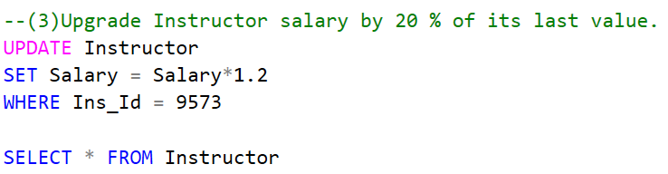

**2) Restore MyCompany DB then**

**Try to create the following Queries:**

1. Display all the employees Data.

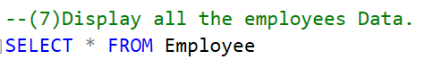

1. Display the employee First name, last name, Salary and Department number.

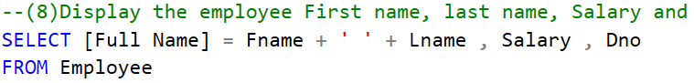

1. Display all the projects names, locations and the department which is responsible about it.

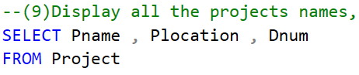

1. If you know that the company policy is to pay an annual commission for each employee with specific percent equals 10% of his/her annual salary .Display each employee full name and his annual commission in an ANNUAL COMM column (alias).

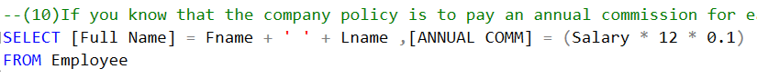

1. Display the employees Id, name who earns more than 1000 LE monthly.

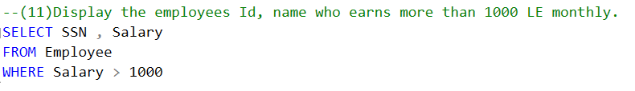

1. Display the employees Id, name who earns more than 10000 LE annually.

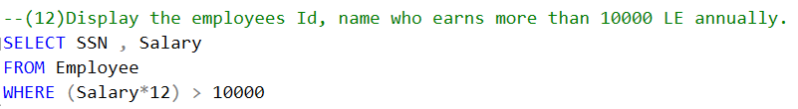

1. Display the names and salaries of the female employees

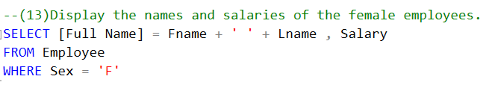

1. Display each department id, name which managed by a manager with id equals 968574.

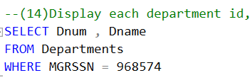

1. Dispaly the ids, names and locations of the pojects which controled with department 10.

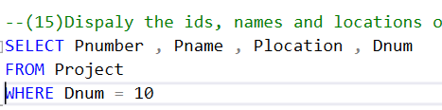

**3) Restore ITI DB then**

1. Retrieve number of students who have a value in their age.

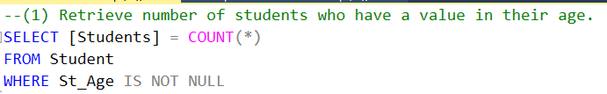

1. Get all instructors Names without repetition

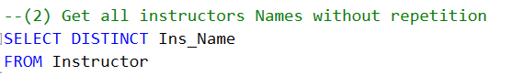

1. Display instructor Name and Department Name

Note: display all the instructors if they are attached to a department or not

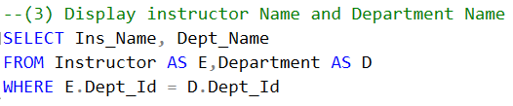

1. Display student full name and the name of the course he is taking

For only courses which have a grade

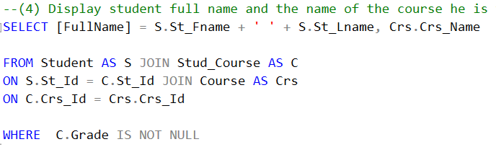

1. Display number of courses for each topic name

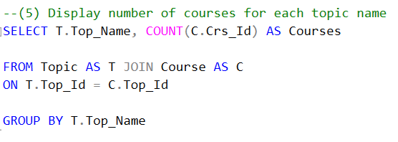

1. Select Student first name and the data of his supervisor

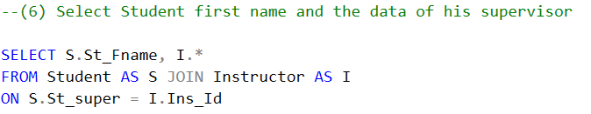

**Bonus**

Display results of the following two statements and explain what is the meaning of @@AnyExpression

select @@VERSION

**It returns a single string containing:**

* The SQL Server product version.
* The operating system version.
* The build number.
* And the SQL Server edition information.

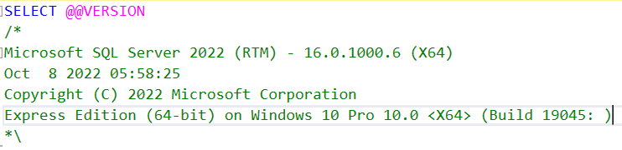

select @@SERVERNAME

**It returns the name of the local SQL Server instance.**

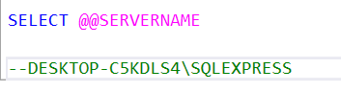

**-- Self-Study Report**

**Class Diagram:**

Class diagrams are the **blueprints** of your system or subsystem. You can use class diagrams to model the objects that make up the system, to display the relationships between the objects, and to describe what those objects do and the services that they provide.

**Built-In Stored Procedure:**

In SQL Server, many administrative and informational activities can be performed by using system stored procedures. The system stored procedures are grouped into the categories shown in the following table.

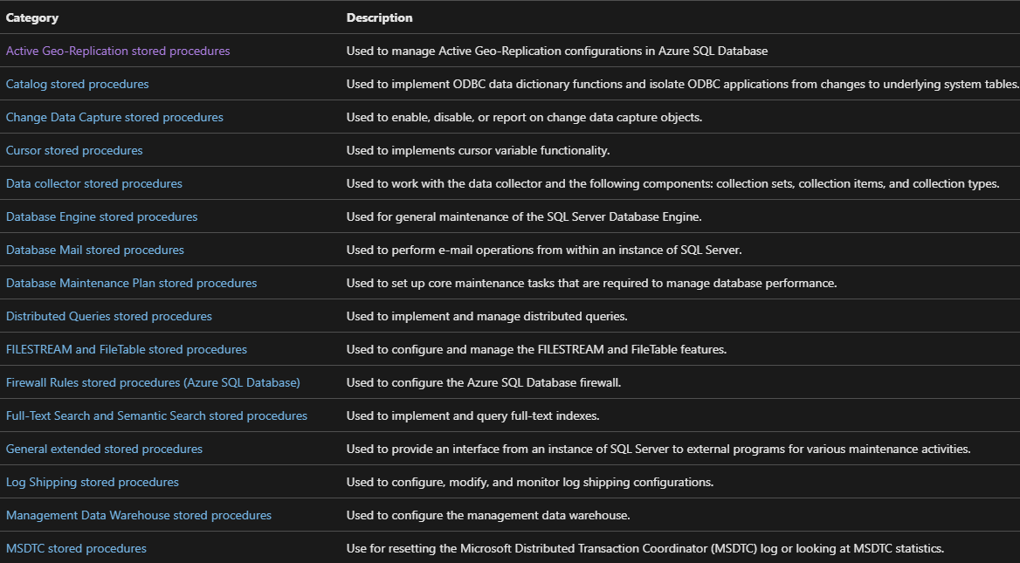

**SQL Injection:**

SQL injection is a code injection technique that might destroy your database.

SQL injection is one of the most common web hacking techniques.

SQL injection is the placement of malicious code in SQL statements, via web page input.

**SQL in Web Pages**

**SQL injection** usually occurs when you ask a user for input, like their username/userID, and instead of a name/id, the user gives you an SQL statement that you will unknowingly run on your database.